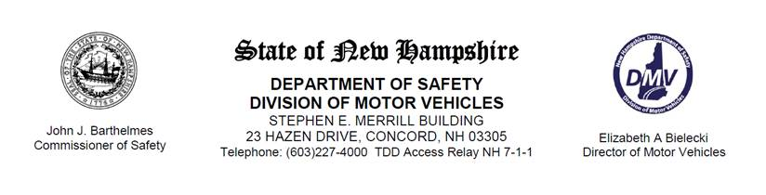

**FOR IMMEDIATE RELEASE/FOR MEDIA ONLY**

Tuesday, August 01, 2017

Larry Crowe, DMV PIO

O: (603) 227-4025, (603) 227-4050

**THE NEW HAMPSHIRE DIVISION OF MOTOR VEHICLES ANNOUNCES CHANGES TO THE MOTOR VEHICLE INSPECTION PROGRAM**

The New Hampshire Division of Motor Vehicles announced today that starting October 1st inspection stickers will be affixed to the lower, driver side corner of a vehicle’s windshield. This change was prompted by many newer model vehicles being equipped with crash avoidance technology located in the area where inspection stickers are currently affixed.

The DMV has also redesigned the existing sticker in order to improve the current inspection sticker issuance process. The new inspection stickers will have both the month and year of expiration printed on them and will contain several new security features including a hologram backer. Certain vehicles, such as motorcycles, will continue to utilize the current inspection stickers.

“The DMV is excited about the upcoming changes,” DMV Director Elizabeth Bielecki said. “By taking advantage of available technology, we are able to gain significant improvements to the vehicle inspection process.”

Visit NH.GOV/DMV for the most up to date information on this and other Division of Motor Vehicles news.

###