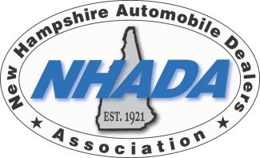

Welcome to NHADA’s DELTA DENTAL BENEFIT PLANS

We cover our members throughout New Hampshire, Maine and Vermont through Delta Dental’s network of dentists, which is the largest in the country.

Members are free to see any dentist they wish but receive the most value when receiving care from a participating provider.

- No Balance Billing
- No Up-Front Payment
- No Claims Paperwork
- Direct payment to participating dentists
- Choose from 6 dental plans
- Choose from 2 networks:
- Premier Plus PPO full network (Dental 1, 1A, 2 and 3)
- PPO smaller network (Dental 5 and 6)
- 2 dual options offering Dental 2 and 3, or Dental 5 and 6 (minimum 20 enrolled)
- Dental 6 includes “Double-Up Max” Carryover Benefit (must have claim for exam or cleaning during a calendar year, paid claims during the calendar year cannot exceed $500, then $250 automatically carried over to the next calendar year)
- Dental 5 and 6 includes orthodontics for children and adults
- Not 2, but 4 cleanings in a calendar year (Who does that? We do!)
- Low Deductibles between $0 and $50 applied to Coverage B and C
- Fluoride treatment twice in a calendar year for your children
- Sealant application to age 19 for your children
- Space maintainers covered for your children
- Guarantee of Service Excellence with meaningful cash refund policy
- All plans include Health through Oral Wellness Program, known as HOW. Additional benefits at no additional charge to members at higher risk for oral disease to receive extra care for better health.

